**Ideation Phase**

**Define the Problem Statements**

|  |  |
| --- | --- |
| Date | 04 October 2022 |
| Team ID | PNT2022TMID31941 |
| Project Name | News Tracker Application |
| Maximum Marks | 2 Marks |

**Customer Problem Statement :**

Problem Statement-1 :

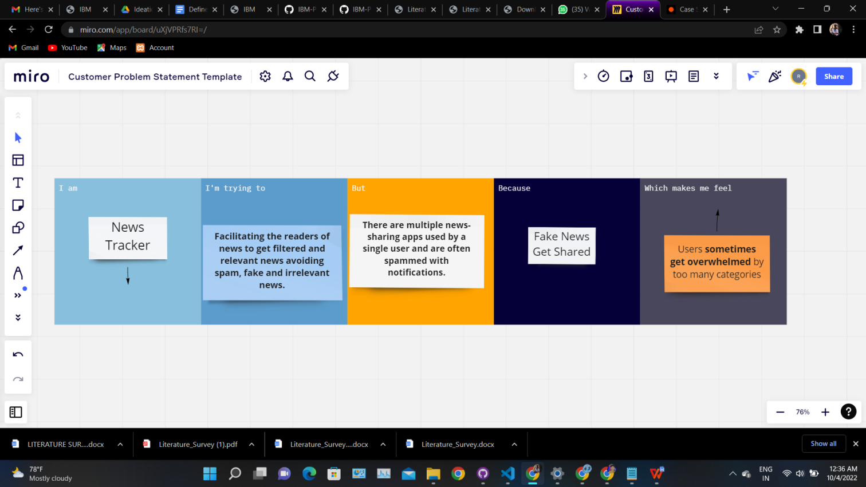

Problem Statement-2 :

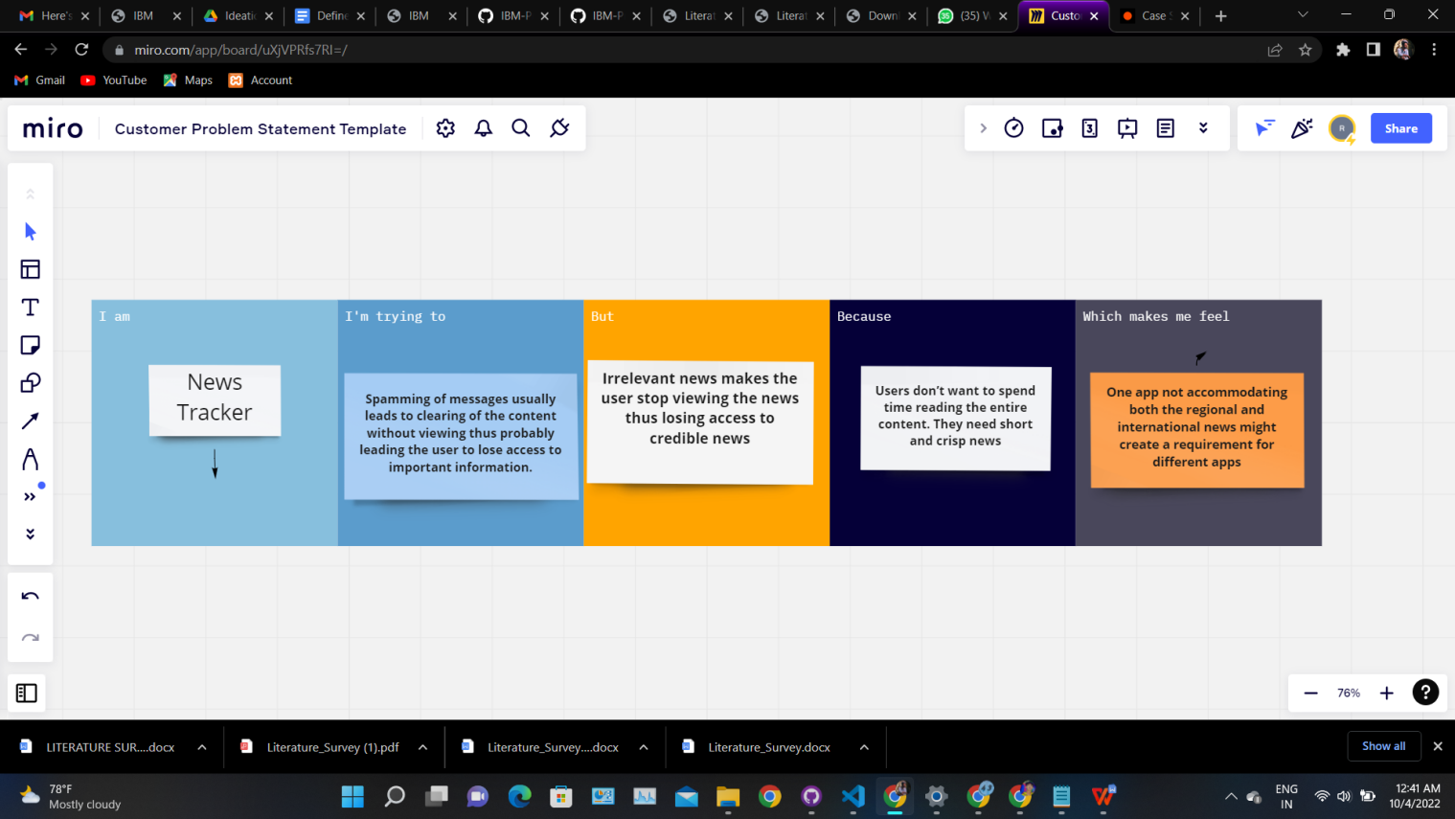

|  |  |  |  |  |  |
| --- | --- | --- | --- | --- | --- |
| **Problem Statement (PS)** | **Iam (Customer)** | **I’m trying to** | **But** | **Because** | **Which makes me feel** |
| PS-1 | News Tracker | **Facilitating the readers of news to get filtered and relevant news avoiding spam, fake and irrelevant news** | There are multiple news-sharing apps used by a single user and are often spammed with notifications. | Fake News Get Shared. | Users **sometimes get overwhelmed** by too many categories. |
| PS-2 | News Tracker | **Spamming of messages usually leads to clearing of the content without viewing thus probably leading the user to lose access to important information.** | **Irrelevant news makes the user stop viewing the news thus losing access to credible news.** | **Users don’t want to spend time reading the entire content. They need short and crisp news.** | **One app not accommodating both the regional and international news might create a requirement for different apps.** |